**SOLAR PANEL DESIGN REPORT.**

**INTRODUCTION:**

* As the demand and prices of electricity have kept on rising, the world looks at renewable energy sources for its power needs. This report details the study of designing a solar powered BLDC Motor Driven Electric vehicle which is one of the solutions for this oncoming crisis.
* This circuit is an integrated system consisting of the solar modules, charge controllers, batteries, and BLDC motor, thus developed as a Solar Powered Electric Vehicle.
* Here 4 Photo Voltaic PV Module have been connected to achieve the required voltage.
* To prevent the battery from overcharging and deep discharge, charge controller is used. It has been very deliberately used to increase the overall efficiency of the charging circuit.

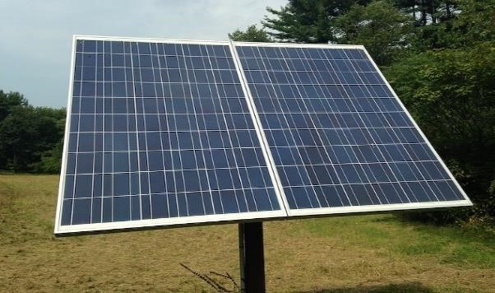

**RULEBOOK CONSTRAINTS:**

* Teams are free to use any standard solar collector which uses photovoltaic cells without reflectors or concentrators. Teams who want to use reflectors, concentrators or some other form of solar collector must send details of the proposed solar collector to the event organizer for approval.
* If the solar collector comprises photovoltaic cells all of the same chemistry, and used without concentrators such as reflectors or lenses, then the total cell area must not exceed the allowable total cell area:

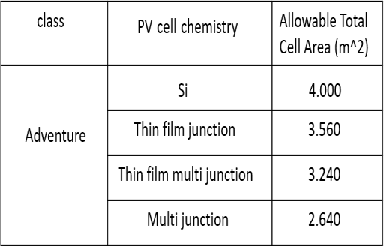

* Teams wanting to use a mixture of photovoltaic cell chemistries must send details to the organizer for approval. If the areas of the different chemistries are area A1 of silicon cells, area A2 of thin film single junction cells, area A3 of thin film multi junction cells and area A4 of multi junction cells then the areas must satisfy

A1 / 4.000 + A2 / 3.560 + A3 / 3.240 + A4 /

2.640 ≤ 1

* All devices used for solar charging must be carried in the solar car. This includes stands, supports and cables.
* Teams are not allowed to place panels over the head and the roof of the driver (cockpit).
* Team are permitted to place solar panels on side of driver provided proper heat and electrical insulation. Position of the panel should not restrict driver’s entry and egress.

The position of the panel should not be higher than shoulder line of the driver.

* Panels should be positioned so that they could be detached for easy inspection of automotive system. They could be either completely detachable, hinged at one end to lift.

**LOAD CONSIDERATIONS:**

* Total wattage of solar panels = 480 W
* Total voltage of Battery, (V) = 51.8V
* Hence max. Charging current (I) = 480/51.8 = 9.27 A
* Total amperage of battery = 80 Ah
* Charging time from only solar panels t =8.63 hours
* This is the charging time that the battery would take to get completely charged. The assumption is that all the panels are exposed to the sunshine with the maximum intensity.

**WORKING PRINCIPLE:**

* A solar cell panel, solar electric panel, photovoltaic(PV) module or solar panel is an assembly of photovoltaic cells mounted in a framework for generating energy. Photovoltaics directly convert solar energy into electricity. They work on the principle of the photovoltaic effect. When certain materials are exposed to light, they absorb photons and release free electrons. This phenomenon is called as the photoelectric effect. Photovoltaic effect is a method of producing direct current electricity based on the principle of the photoelectric effect. A solar cell or photo-voltaic(PV) cell consists of a

layer of p-type silicon placed next to a layer of ntype silicon. In the n-type layer, there is an excess of electrons, and in the p-type layer, there is an excess of positively charged holes (which are vacancies due to the lack of valence electrons). When both the ptype and n-type layers are joined together, then the electrons from the n-type layer starts moving towards the holes in the p-type region near the junction. This creates an area called the depletion region around the junction where the electrons fill the holes.

* When each hole in the depletion region is filled with electrons, the p-type region now has negatively charged ions, where holes were present initially, and the n-type region has positively charged ions, which has electrons initially due to the built-in electric field

and induced potential difference across the junction. Due to the presence of oppositely charged ions, an internal electric field is built in between the depletion layer, which prevents the electron in the nregion to recombine with the holes in the p region. When the sunlight falls on the surface of solar cells, it absorbs some photons, and some of these absorbed photons, which have more energy than that of the energy bandgap (the gap between the conduction band and the valence band of the semiconductors crystal used in the construction of solar cells) will be able to eject out the electrons from the bond, which results in the formation of electron-hole pairs, these are known as the light generated electron-hole pair. If the electrons are ejected from the depletion layer, the electric field will force the electrons to move in the n-type region and holes to the p-type layer. If we connect an external load, the electrons from the ntype region will travel to the p-type region through the depletion region and then passes through the external wires connected at the back of the n-type layer, hence the flow of electricity begins. Based on the principle of photovoltaic effect, solar cells or photovoltaic cells are made. They convert sunlight into direct current (DC) electricity. But, a single photovoltaic cell does not produce enough amount of electricity.

Therefore, a number of photovoltaic cells are mounted on a supporting frame and are electrically connected to each other to form a photovoltaic module or **solar panel**.

**DESIGN CONSIDERATION:**

* Two panels of 146.5 X 66.6 cm is used.
* Two panels of 70 X 50 cm is used.

**COMPONENT SELECTION:**

* Four mono-crystalline panels total of 480-Watt peak power.

**METHODOLOGY TO BE USED FOR MORE**

**EFFICIENCY OF SOLAR PANEL:**

* Panels with parallel wiring with individual charge controller can improve clean energy generation efficiency up to 15% more and may be helpful. Improvement in efficiency brought by parallel wiring may also reduce requirements of sizing of batteries as state of charge of batteries will Improve
* Since more is the temperature less will be the efficiency of solar panels. So, we used THIN-FILM PANELS of GALLIUM-ARSENIDE Panels are much less sensitive to heat.
* To cooling the panels, we used Water Spray.

**FORMULATIONS AND CALCULATIONS:**

. The first factor need to be taken into account because

Peak power given by the panels = 480 W

* Power available = 480-15%*480 (taking 15% as a safe margin) = 408 W
* For the second factor we assume that the vehicle will start at zero gradeability, and that after the vehicle is set into motion some gradeability up to 7.25 degrees (which is normal for Indian roads) may or may not be present. Voltage applied by the panels across the load (BLDC motor) = 48V
* Maximum value of current available across the windings of the motor = 408/48 = 8.5A • Rolling resistance coefficient µ is taken 0.02 (Wikipedia).
* Tractive effort required = rolling friction = µ X Mg = 0.02 X 262 X 9.8 N = 51.352N
* Tractive torque effort required= f x r =51.352 x 0.15 N-m = 7.7028 Nm. From data our solar power of 480 watt overcome the tractive effort torque.

**RESULTS:**

* Since our electric vehicle will be covering small distances the value of Air mass and Tilt angle will depend mostly on the absolute position of sun.
* For our monocrystalline solar cell, the maximum efficiency is 21%-25% but for different orientations of the sun throughout the day (different tilt angles) the overall efficiency or optimum efficiency is around 15%-18%.
* So, we have made our design incorporating the Tilt angle and Air mass in such a way that for all positions of the sun the four panels which will operate at its maximum efficiency.

**SOLAR CONTROLLER / MPPT DESIGN REPORT** **INTRODUCTION:**

* A Solar Charge Controller works by regulating the voltage and current flow from solar panels to a battery. It regulates the amperage and voltage that is delivered to the loads and any excess power is delivered to the battery system so the batteries maintain their state of charge without getting overcharged. The controller maintains a float charge to keep the battery ready for use.
* Most “12 volt” panels put out about 16 to 20 volts, so if there is no regulation the batteries will be damaged from overcharging, as most batteries need around 14 to 14.5 volt to get fully charged.

**RULEBOOK CONSTRAINTS:**

* Solar Panels must be capable of charging the batteries using definite charge controllers used for this purpose.
* Teams should make sure that fluctuating Direct Current should not reach Battery Pack directly.
* There should be usage of any charge controllers through which fluctuating direct current from solar panel is converted into DC current and supplied to the Batteries.
* Team is required to remove the battery terminals (both +Ve and –Ve) from the motor controller and

connect the Motor controller directly to Solar charge controller.

* There should be no Super capacitor circuit or any other device which stores the charge involved in

between Solar Charge Controller and Motor

controller

**WORKING PRINCIPLE:**

* A Solar Charge Controller works by regulating the voltage and current flow from solar panels to a

battery. It detects and monitors the battery voltage,

reducing the current when the battery is fully charged. The controller maintains a float charge to keep the battery ready for use.

* The MaximumPowerPoint of a solar panel is the voltage at which they can produce the maximum charging power to the batteries. The controller compares the batteryvoltage with the solar panel and converts the panel voltage into the value which maximises the current into the battery.
* More charge controllers utilized a mechanical relay to open or shut the circuit, halting or beginning power heading off to the electric storage devices.
* The solar charge controllers can also control the

reverse power flow. The charge controllers can

distinguish when no power is originating from the solar panels and open the circuit separating the solar

panels from the battery devices and halting the reverse current flow.

**LOAD CONSIDERATION, DESIGN**

**CONSIDERATION AND COMPONENT**

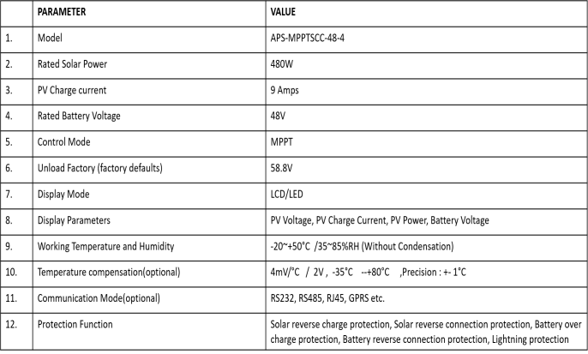

**RESULTS:-**

* From the calculations mentioned above, we have

found out the values for

* + 1. Power = 480 W
    2. Voltage = 48V
    3. Current = 9 AMPS